1. Show the NRZ encoding for the following bit pattern.



1. NRZ encoding can result in several consecutive ones and zeroes. Why is this a problem?

This is a problem because you can have a wandering clock reference voltage if there are many consecutive ones or zeros. When many consecutive ones or zeroes occur, the receiver has a hard time distinguishing the clock cycle, so there is the possibility that the receiver becomes desynchronized from the host.

1. Show the Manchester encoding for the following bit pattern.



1. What is the primary drawback to Manchester encoding?

You can only send data at half the bandwidth of a non-encoded signal, since there are potentially two transitions per bit received (once in the middle of reception and once at the end of reception)

1. Show the NRZI encoding for the following bit pattern. Assume the signal starts low.



1. What NRZ problem does NRZI encoding fix?

This fixes the problem of consecutive ones but it doesn’t necessarily prevent multiple consecutive zeros.

1. Show the 4B/5B encoding and draw the resulting NRZI signal for the following bit sequence. Assume the NRZI sequence starts high.

4B 0000 0001 1010 0111 0100

5B 11110 01001 10110 01111 01010

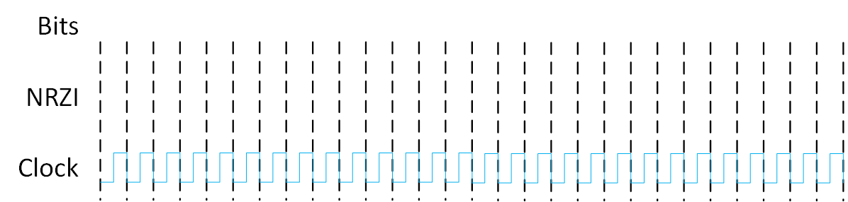



1. What benefit is there to using 4B/5B encoding before using NRZI encoding?

4b/5b encoding guarantees that there will never be more than 3 consecutive zeros, meaning that it will not suffer from the trailing baseline problems possible in NRZ or NRZI encoding.